**Chapter 4**

**Analysis Modeling**

**4.1 Activity Diagram**

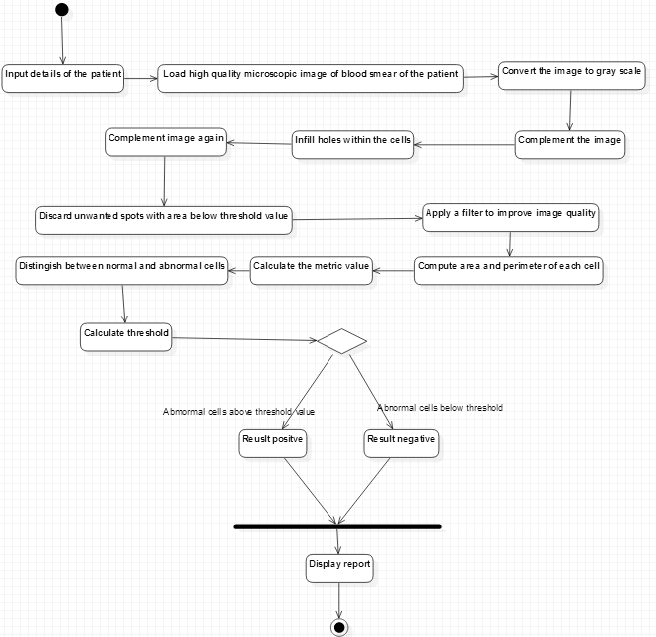

Fig. 4.1.1 Activity Diagram

**4.2 Functional Modeling**

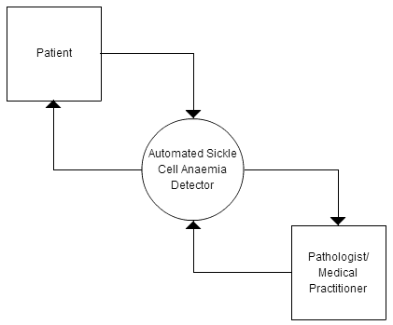

Fig. 4.2.1 Data Flow Diagram (Level 0)

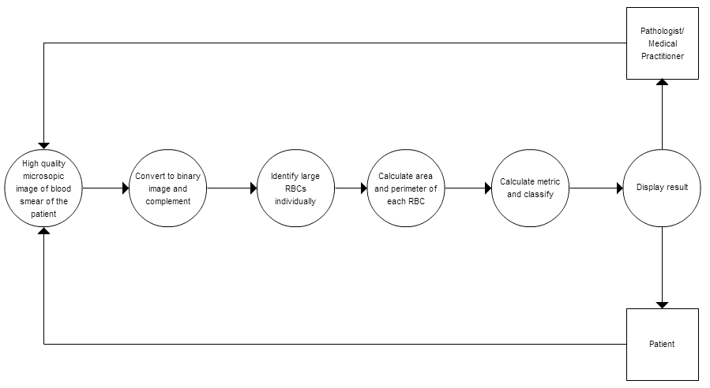

Fig. 4.2.2 Data Flow Diagram (Level 1)

**4.3 Timeline chart**

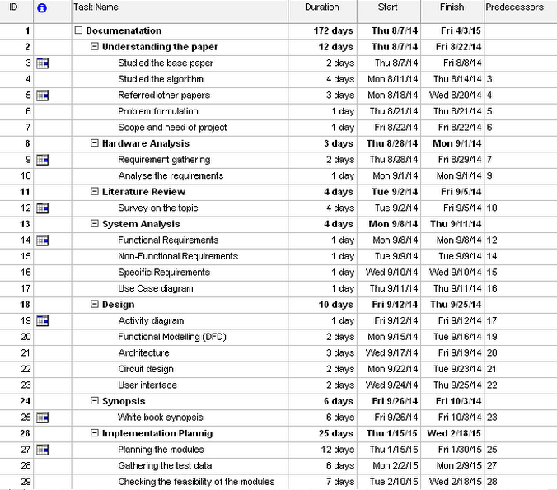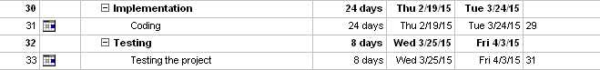

Figure 4.1 TimeLine Chart

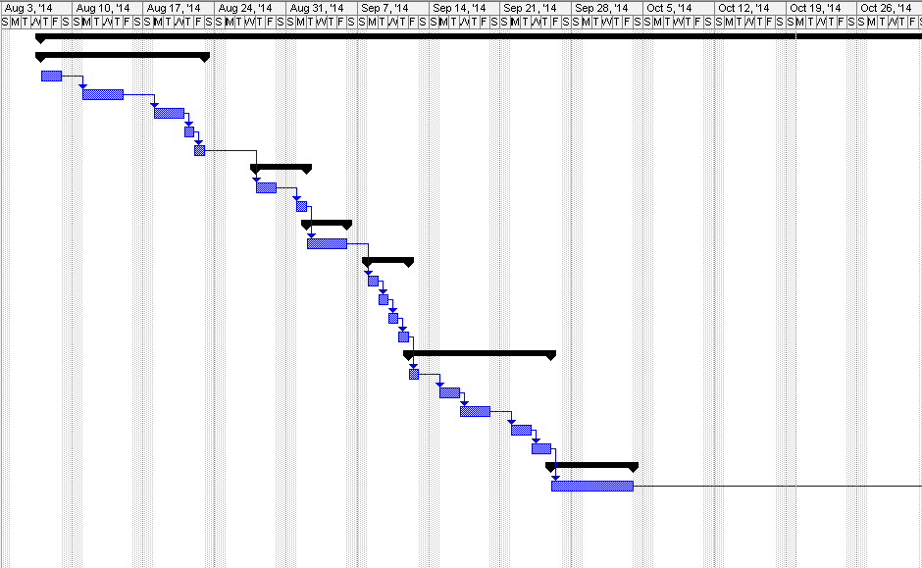

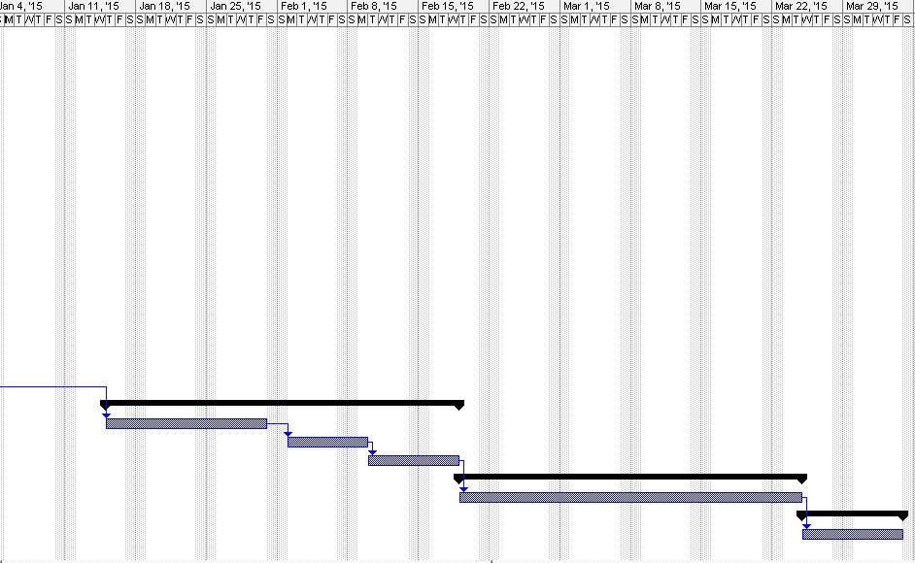

Figure 4.2 Gantt chart